Tugas daspro Pertemuan 9
Vandi Raditya Firmansyah/29
TI-1C / 264107020197
Latian 1
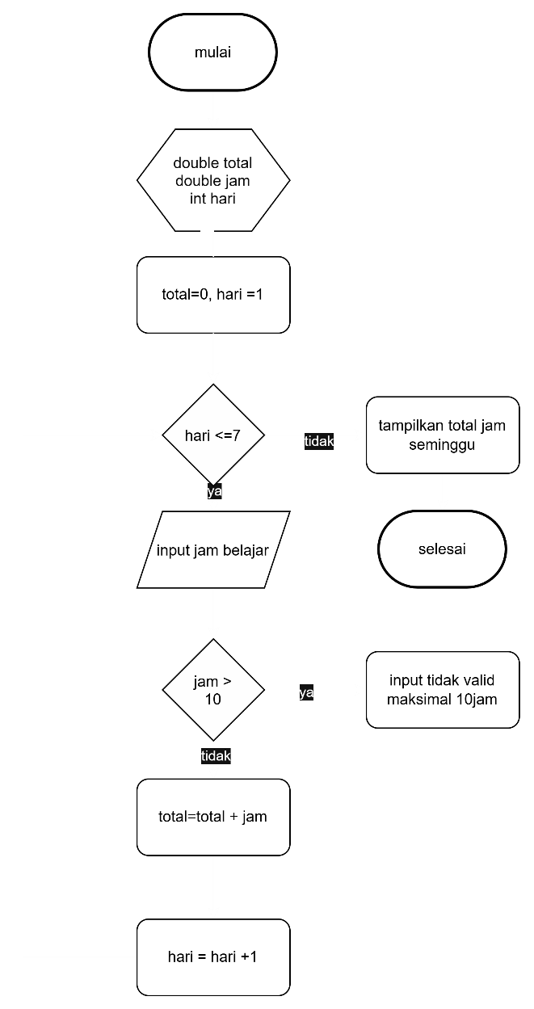

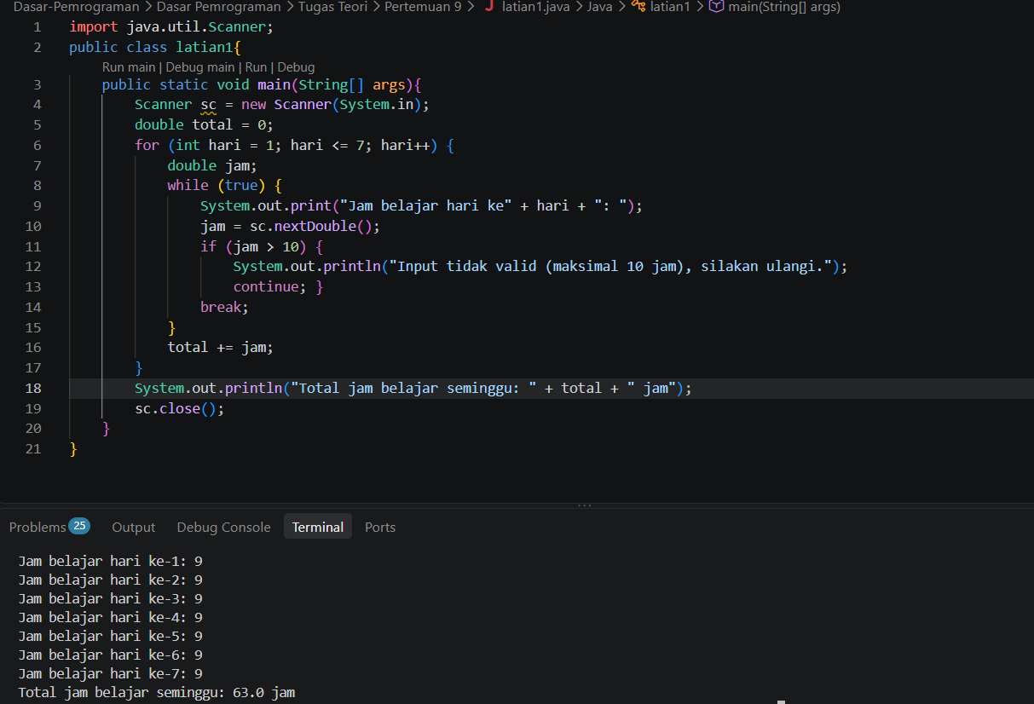
Menghitung jam belajar
Double jam,total
Int hari
Set Jam = 0
Set hari = 1
WHILE hari <= 7 DO
INPUT jamBelajar
IF jamBelajar > 10 THEN
OUTPUT "Input tidak valid, masukkan ulang"
CONTINUE
ELSE
totalJam = totalJam + jamBelajar
hari = hari + 1
ENDIF
ENDWHILE
OUTPUT "Total jam belajar selama seminggu: ", total
Selesai

Latian2
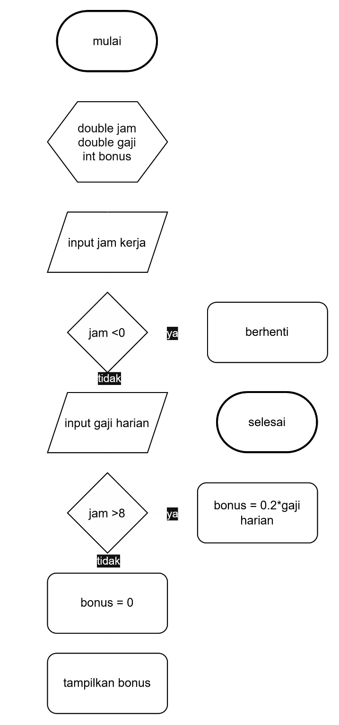

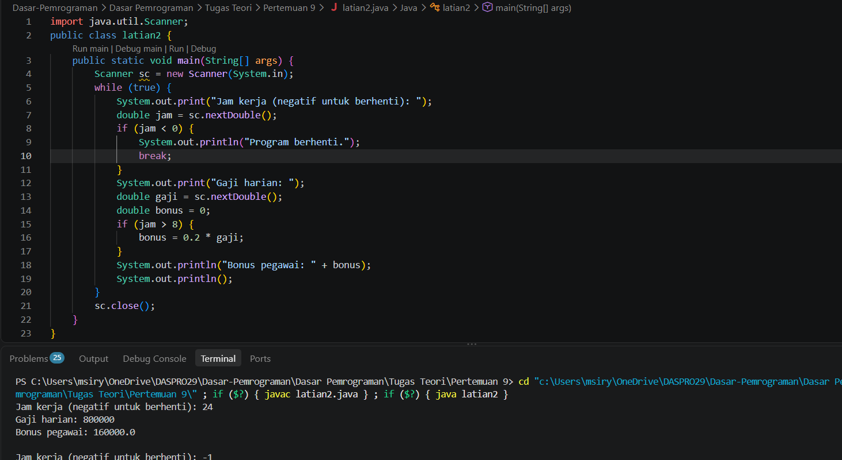
Menghitung bonus
Double jam, gaji,bonus
WHILE true DO
INPUT jamKerja
IF jamKerja < 0 THEN
BREAK
ENDIF
INPUT gajiHarian
IF jamKerja > 8 THEN
bonus = gajiHarian * 0.2
ELSE
bonus = 0
ENDIF
OUTPUT "Bonus pegawai: ", bonus
ENDWHILE
Selesai

